**Aletta Year Challenge – QGIS manual**

**Table of contents**

1. Intro
2. Downloading QGIS
3. Checking the prerequisites
4. Creating a map using Lifelines data

**1. Intro**

Dear student,

With this manual you will be able to create data visualizations and maps on which you can plot the data. The instructions will introduce you to using QGIS, a free and open source geographic information system. The applications of QGIS are very broad and the tool has a lot of features to use for geographical analyses. With this manual you will learn the basics of creating your first map using the Lifelines data.

If you need any advanced help in using QGIS or you would like to learn more about performing geographical analyses on the data, feel free to ask the Geodienst for assistance. You can send them an e-mail on [geodienst@rug.nl](mailto:geodienst@rug.nl).

Good luck!

Aletta School for Public Health  
Lifelines

**2. Downloading QGIS**

The latest version of QGIS can be downloaded here: <https://qgis.org/en/site/forusers/download.html>

**3. Checking the prerequisites**

To create your first map we will require two things:

1. *Geospatial vector data file, called a Shapefile*

The shapefile format is used in GIS mapping to represent real world objects by storing information about their location, shape, and attributes of geographic features on a map. In this case we’ll use a shapefile that represents the Netherlands and its zip codes.

1. *Lifelines dataset prepared for QGIS*

We have prepared data files specifically for the use of QGIS and creating your first map. The biggest difference in comparison to the other data files is that the data points have been rounded to numbers without decimals. This will make it easier to load the data into QGIS without additional data preparation steps.

Make sure that you use the data provided in the qgis folder while going through the steps of this manual

**4. Creating a map using Lifelines data**

**Step 1: Open QGIS**

After installing QGIS, you can open the application by selecting the executable: “QGIS Desktop 3.32.1”

**Step 2: Open the data file**

The first step is loading the data into QGIS. You can do this by clicking on the icon indicated by the arrow in the image below.

**Step 3: Load the data**

Select the location of the data file and make sure that the ‘Sample Data’ resembles the example given in the image. For this example, use the file “Participants_Aggregated_Zipcode_General.txt” The variables should automatically be assigned the format of ‘Integer (32) bit’, otherwise you will have difficulties plotting the data onto the map.

Click ‘Add’ and ‘Close’ to return.

**Step 3: Load the Shapefile**

After loading the dataset, which is now visible in the layer section, drag the Shapefile on the section. You can do this by finding the included PC4.shp file in the file explorer of QGIS, as shown in the image. After finding the file, simply drag it over.

If you see an additional screen after having dragged the Shapefile, simply continue by confirming.

**Step 4: Open the properties of the Shape layer**

Now that you have loaded the Shapefile and have created a layer, you will see a map of The Netherlands in a random colour. To proceed, right click on the layer and go to ‘Properties’.

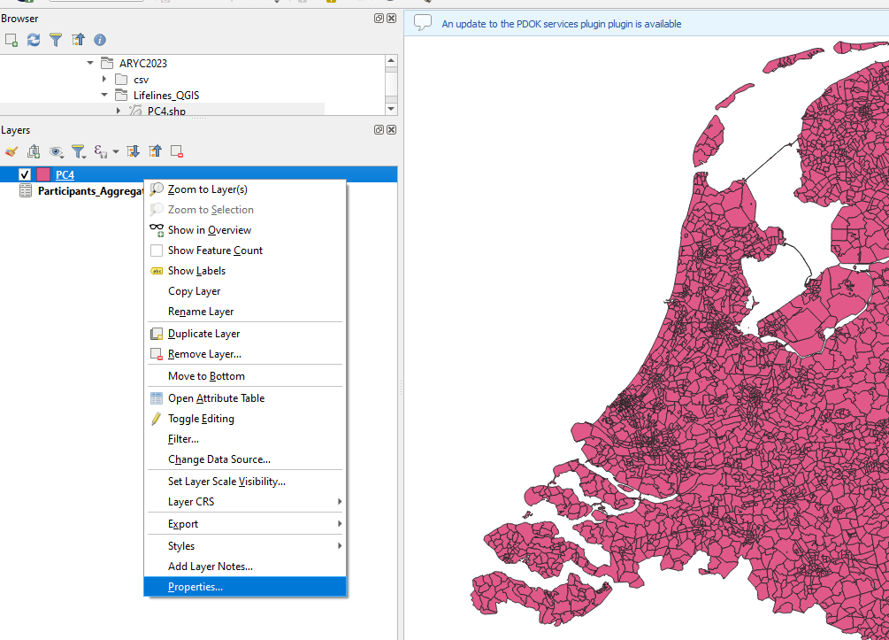

**Step 5: Join the Data layer and the Shape layer**

In properties, go to ‘Layer Properties’ and click on the plus (‘+’) to add a new join. We will now join the Data layer and the Shape layer.

**Step 6: Verify the join**

QGIS should automatically recognize that you want to join the Data layer. Make sure that the ‘Join field’ is the variables from the Data layer (in this case the ‘ZIPCODE’-variable) and that the ‘Target field’ is the variable from the Shape layer (in this case the ‘postcode’-variable). A common problem that may occur is that the Data layer is not loaded correctly and that the ZIPCODE-variable is assigned the right format (as explained in step 2). If this is the case, try changing the data file and retry step 2.

**Step 7: Duplicate layer**

Now that the data is joined, you can duplicate the Shape layer to modify the visualization of the data. The new duplicate layer will be used to draw the data on top of the original Shape layer.

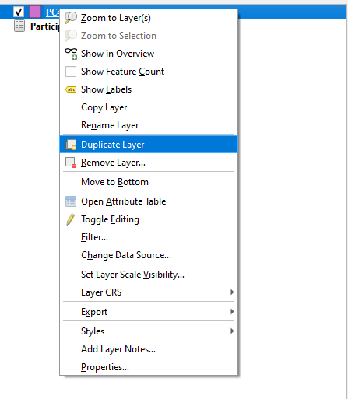

**Step 8: Open the properties of the copied Shape layer**

Right click on the copied Shape layer and go to ‘Properties’.

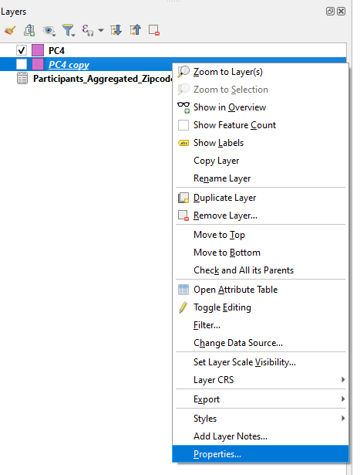

**Step 9: Open the Symbology feature and change the symbol**

In the properties of the copied Shape layer, go to the Symbology feature. In this feature you will see the base colour which was randomly assigned to draw the map of the Netherlands (in this case pink). Click on the dropdown-menu that says ‘Single Symbol’ to select the value ‘Graduated’.

**Step 10: Select the data variable you want to draw**

Having selected ‘Graduated’ you will now have the option to select a ‘Value’. You can select a variable from the joined Data layer to be drawn on your map. In this example we will draw the AGE_T1 variable on the map.

**Step 11: Classify and group your data**

After having selected the variable you can indicate how the data should be split over different classes. In this case we’ll leave the Classes on the default value (‘5’). You can now select ‘Classify’ and QGIS will group the data of the variable over 5 different classes.

**Step 12: Check the box before the copied Shape layer and drag it above the original Shape layer**

The data is now loaded, but isn’t visible yet on the map. You will need to check the box before the layer and drag the layer one level higher, above the original Shape layer. After you’ve done so, the drawn data will be visible on top of the original Shape layer, as shown in the image.

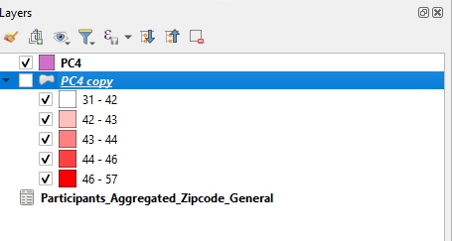

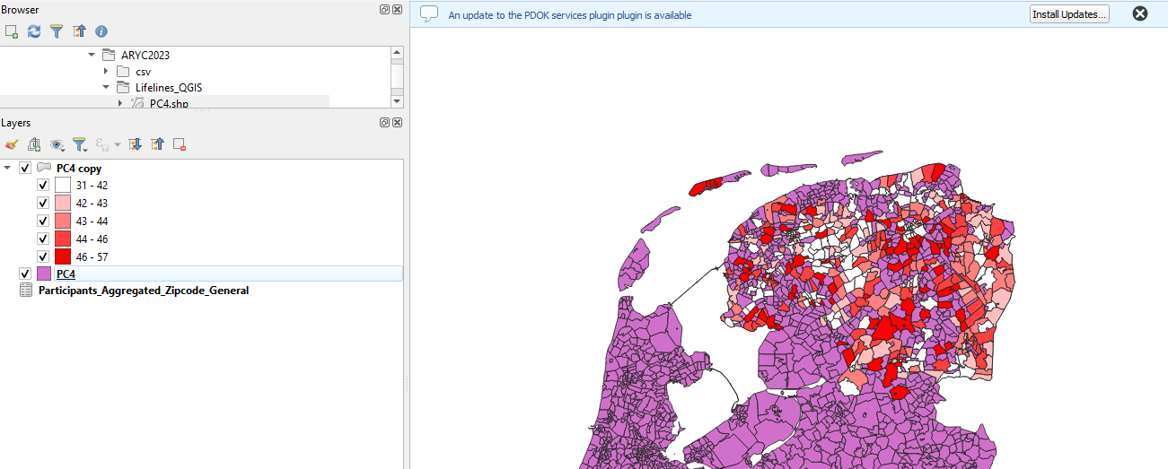

**Step 13: Change the base colour**

To create a better image, you may want to change the base colour of your original Shape layer. You can do so by selecting the ‘Properties’ of the original Shape layer and go to the ‘Symbology’ feature. You can the Color of the map. Additionally, you can also decrease the ‘Opacity’ which will give a better highlight to the drawn data.

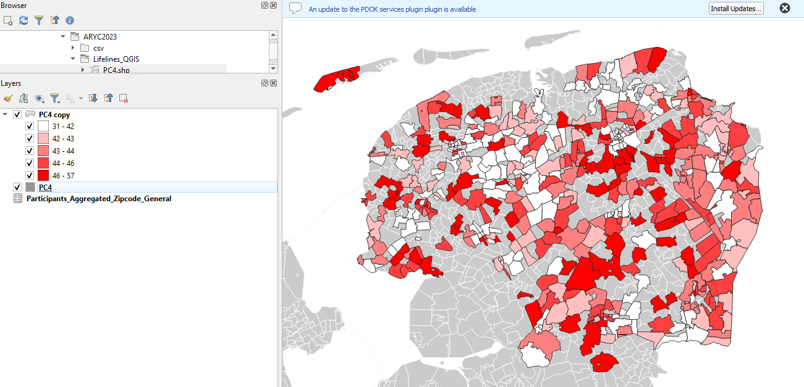

Congratulations, you have created your data visualization! To continue, you can now experiment with different variables and symbology’s. Make sure that you copy the base Shape layer anytime you want to try and visualize data and keep in mind that the order of the layers matters.